Daniel Williamson

Project #5

4/12/17

EE 222

Project Overview

Purpose:

The purpose of this project was to implement a working stack and queue. By asking a user to enter commands and input integers to that they can pop/push and enqueue/dequeue from an array of integers. We were given a functional linked list and all the functions of adding and stuff.

Approach:

TO begin, I needed to understand what the files provided were doing. Thankfully, once again, unlike the previous project, it was rather clear and easy on what was needed to be done. Having just the one make file, made it much more clear. After getting the code to run I started filling in the functions. I started with creation of pushing and popping. And then went to the stack.c file to get that functioning. Once the commands were working with correctly. I moved onto enqueueing and dequeuing along with the queue.c file.

Results:

This is a photo of pushing to a stack, I push three integers: 5, 1, and 9. And then print it out.

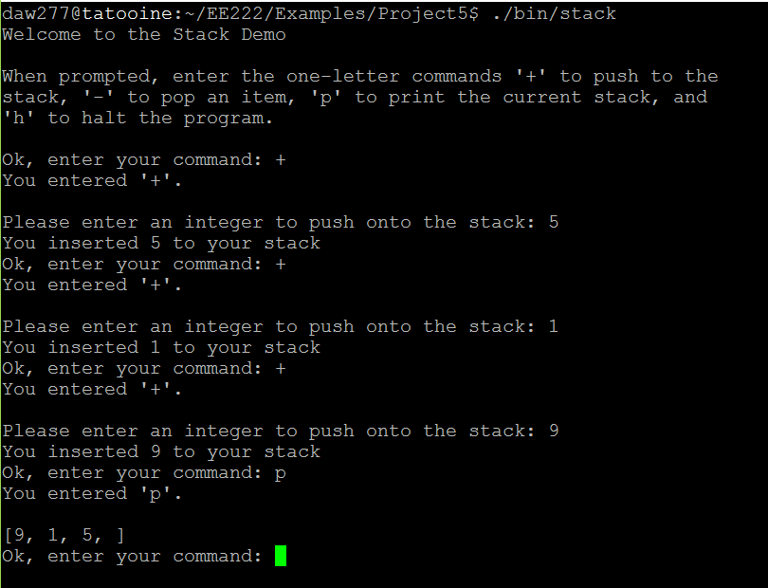

This is a photo of me popping from a stack. I use the pop command which should remove the top integer. Which it does:

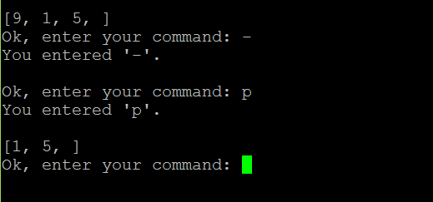

This is a photo of enqueueing. I queue: 5, 8, and 2. Then use the print command to print them out.

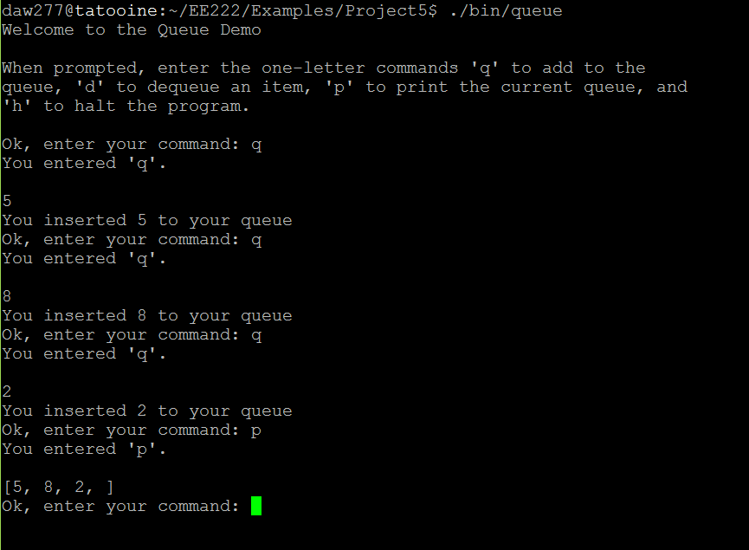

I then dequeue from the queue. In this photo, I use the dequeue command twice. Which leaves me with just 2:

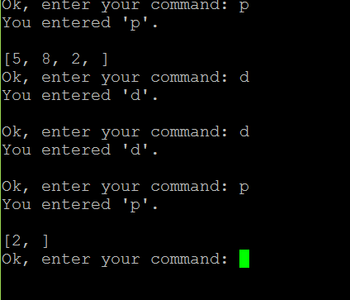

Conclusion:

In conclusion, this was a rather easy lab. Understanding how the stacks and queue work made this project simpler. Writing and drawing it out made it much easier. The most difficult part I ran into was getting the integer array to work and cast properly. It was giving me lots of errors. To overcome this, I spoke to a few friends and they pointed out to me the mistake I was making.